ROUNDING
KS1 – 2001 Paper
1.
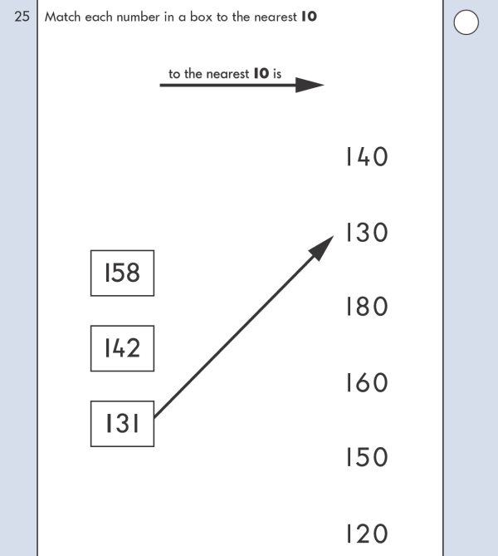
KS1 – 2003 Paper 2
2.
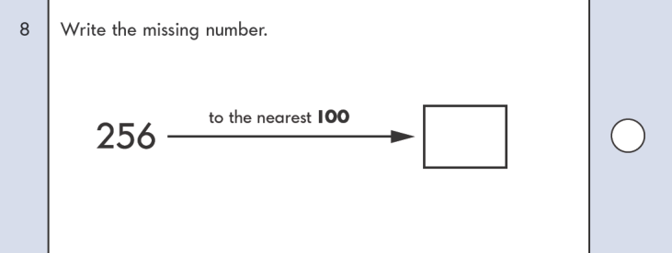
KS1 – 2005 Paper 1
3.
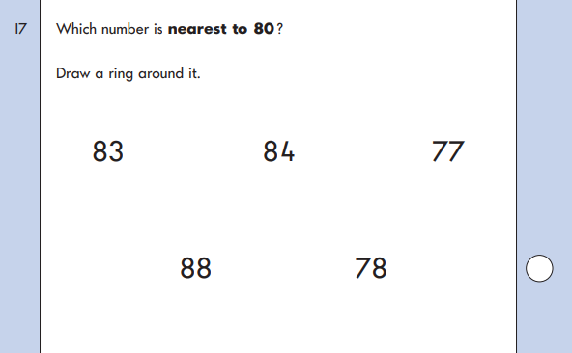
KS1 – 2007 Paper 1
4.
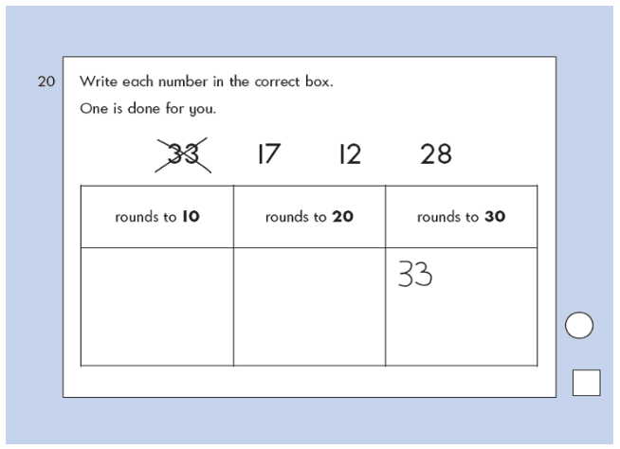
KS1 – 2007 Paper 2
5.
